

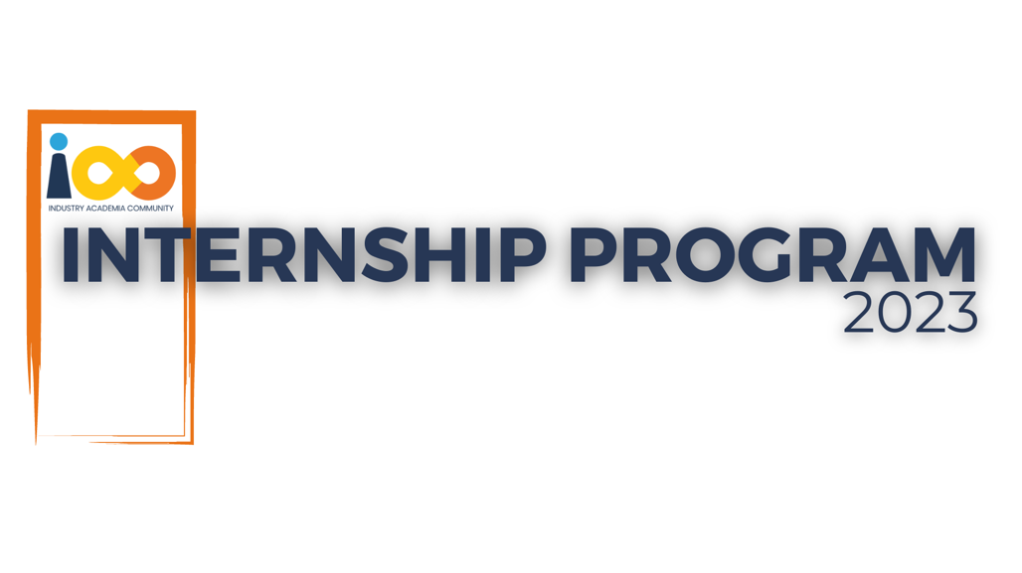

PROJECT REPORT

Data Analysis  
  
Student Performance Analysis

|  |  |  |  |
| --- | --- | --- | --- |
| **Created By:** | Shruti Ganesh Wagh | **Approved By:** | <Domain Lead Name> |
| **Created On:** | 15-08-2024 | **Approved On:** | DD-MMM-YYYY |

Page left blank intentionally

**INDEX**

**1** **PROJECT DETAILS** 2

**2** **SUMMARY** 2

**3** **INTRODUCTION** 2

3.1 Background 2

3.2 Stakeholders 2

3.3 Objectives 2

**4** **METHODOLOGY** 2

4.1 Considerations & Assumption 3

4.2 Approach 3

4.3 Activities 3

**5** **TARGETTED V/S ACHIEVED OUTPUT** 3

**6** **CONCLUSION** 3

**7** **APPENDICES** 4

7.1 Appendix A – Title 4

**General Instructions for using the Live Project Report Template**

* This template and the subsequent document created using this template is a confidential document and is the intellectual property of Cloud Counselage Pvt. Ltd. Circulating it outside of the organisation without the consent of Cloud Counselage Pvt. Ltd. is the breach of company policies and will lead to legal actions
* This template is a guideline document to communicate the implementation of design ideas and the results of the work to the stakeholders.
* The **text between inequality (< >) is to be replaced** by relevant text
* Please **remove the yellow highlight on the Text** between the inequality (< >). This is done to help you notice the text to be changed/replaced
* The text in *italics* highlighted in grey is just for reference and should be removed after adding the relevant text

# **PROJECT DETAILS**

|  |  |  |  |
| --- | --- | --- | --- |
| **Project Name** | Shruti Ganesh Wagh | | |
| **Project Sponsor** |  | | |
| **Project Manager** | Harshada Topale | | |
| **Start Date** | 15-08-2024 | **Completion Date** | 05-09-2-24 |

# **SUMMARY**

# Conducted a comprehensive analysis of student interns, focusing on the relationships between academic performance, event participation, career aspirations, and key success factors. Utilized data visualization tools like Power BI to generate actionable insights.

# **INTRODUCTION**

## Background

This project aims to analyze data about student interns to better understand the factors impacting their academic success, career goals, and involvement in events. Using a dataset that includes details on academic performance, event participation, career interests, and other key factors, we want to uncover patterns and insights that highlight what contributes to student success. This information will help our institution make better decisions to support student growth, improve engagement, and provide relevant opportunities that align with their aspirations.

## Stakeholders

The primary stakeholders in this project include:

1. Students: Beneficiaries of insights that can help guide their academic and career paths.
2. Career Services and Academic Advisors: Individuals who can utilize the findings to provide targeted guidance, resources, and support for students.
3. University Administration and Event Organizers: Teams responsible for planning and promoting events, who can leverage insights to increase student engagement and participation.

4. Hiring Managers and Recruiters: External stakeholders interested in understanding trends in student skills, career readiness, and key success factors for internship candidates.

## Objectives

*The project aimed to analyze various aspects of student interns' academic performance, event participation, and career aspirations to identify factors that drive their success. Key objectives include:*

1. *Identify Relationships: Establish connections between GPA, event participation, and career goals to provide actionable insights for student support.*
2. *Enhance Event Engagement: Determine which promotion channels and event types most effectively attract students to encourage higher participation.*

*3. Provide Data-Driven Guidance: Offer university staff and career advisors clear insights to guide students more effectively in their academic and career pursuits.*

*All original objectives have been achieved, with minor additions to explore salary expectations based on skills and experience, as discussed post-Project Charter approval.*

# **METHODOLOGY**

These conventions are all about the positions of line breaks, how many characters should go on a line, and everything in between.

## Considerations & Assumption

This project required careful consideration of the dataset's quality, limitations, and potential biases to ensure accurate analysis. Assumptions were made about the consistency and relevance of the available data attributes, like GPA, event participation, and career goals. These assumptions were essential for shaping the analysis focus and identifying reliable trends despite any data gaps or inconsistencies.

## Approach

## A structured, data-driven approach was used to address the project objectives, ensuring insights were based on well-defined metrics. This included descriptive analysis to understand baseline trends, correlation analysis to explore relationships among variables, and visualization to highlight key findings. This approach was chosen to keep the analysis clear, actionable, and aligned with project goals.

## Activities

• Conducted requirement gathering to align project goals with stakeholder expectations.

• Planned the project phases, focusing on data collection, preparation, and analysis.

• Performed data cleaning, transformation, and visualization to prepare for analysis.

• Generated insights and drafted a presentation to communicate findings effectively.

# **TARGETTED V/S ACHIEVED OUTPUT**

The project set out to deliver insights on what factors impact the success of student interns, focusing on academic performance, event participation, and career aspirations. The targeted output was to identify relationships between variables like GPA, event involvement, and skill development to help advisors, event organizers, and career services provide better support and guidance for students.

**Achieved Output:**

The analysis successfully met these objectives, revealing important trends and connections, such as how GPA and event engagement relate to career goals, which promotion channels attract the most participation, and how skills like programming experience impact salary expectations. The final output included a set of visualizations and summaries that communicate these findings clearly, offering practical recommendations for stakeholders.

**Deviations and Reasons:**

There were only minor deviations, primarily in the data preparation phase. Initial dataset inconsistencies required some adjustments in the data cleaning process to ensure accuracy. This deviation served as a valuable lesson in performing detailed data checks upfront, helping avoid similar issues in future projects. Overall, these changes contributed positively by enhancing the clarity and reliability of the analysis without affecting project goals or timelines.

# **CONCLUSION**

This Project provides valuable insights that will enable stakeholders to make informed decisions about supporting student interns more effectively. By identifying key factors that impact interns' success—such as academic performance, event participation, and career aspirations—stakeholders can better understand the needs and challenges of interns, allowing for tailored support strategies that improve their overall performance and experience.

**Future Scope:**

1. **Enhanced Support Programs:** The insights can be used to develop targeted support programs, such as mentoring, skills training, and career counseling, aimed at improving areas that are strongly correlated with intern success.
2. **Longitudinal Analysis:** By expanding the project to include data from multiple years, future analysis can identify trends over time, helping stakeholders anticipate evolving needs and adapt strategies accordingly.
3. **Predictive Modelling:** The project’s findings can serve as the foundation for predictive modelling, enabling stakeholders to proactively identify interns at risk of underperformance and provide timely interventions.

In summary, this project not only delivers immediate insights but also establishes a basis for continuous improvement in internship programs, benefiting both current and future cohorts of student interns.

# **APPENDICES**

## Appendix A – Project Components Table

